**Batch information:**

* **Batch Start Date: 2025-08-04**
* **Batch Name: WiproNGA_DWS_B5_25VID2550**
* **First Name: Seetal**
* **Last Name: Biswal**
* **User Id: 34933**
* **Batch ID: 25VID2550**
* **Assignment-** Doc of all commands used

**Execute Process:** Execute-Process is a command used in some automation tools, such as PowerShell App Deployment Toolkit (PSADT), to execute a process or run an executable file**.**

**Example1:**Execute-Process -Path "$dirFiles\Bin\setup.exe" -Parameters '/S' -WindowStyle 'Hidden'

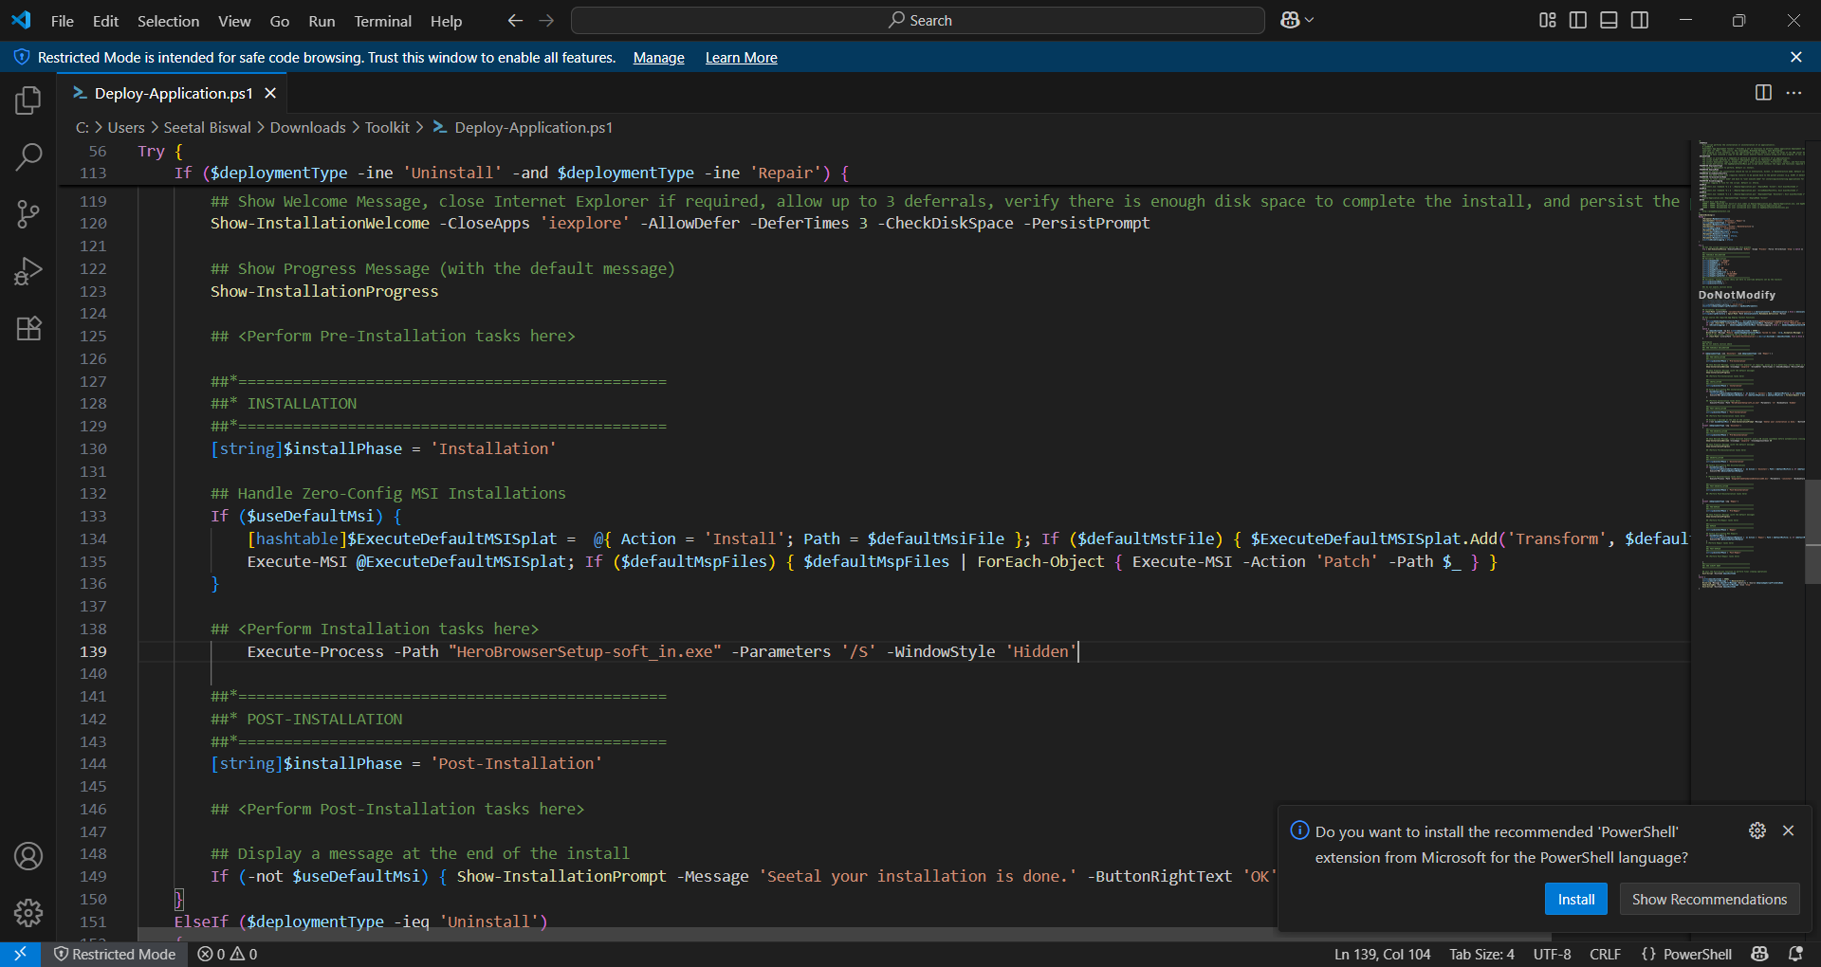

**Example 2**: Execute-Process -Path 'setup.exe' -Parameters '/S' -IgnoreExitCodes '1,2'

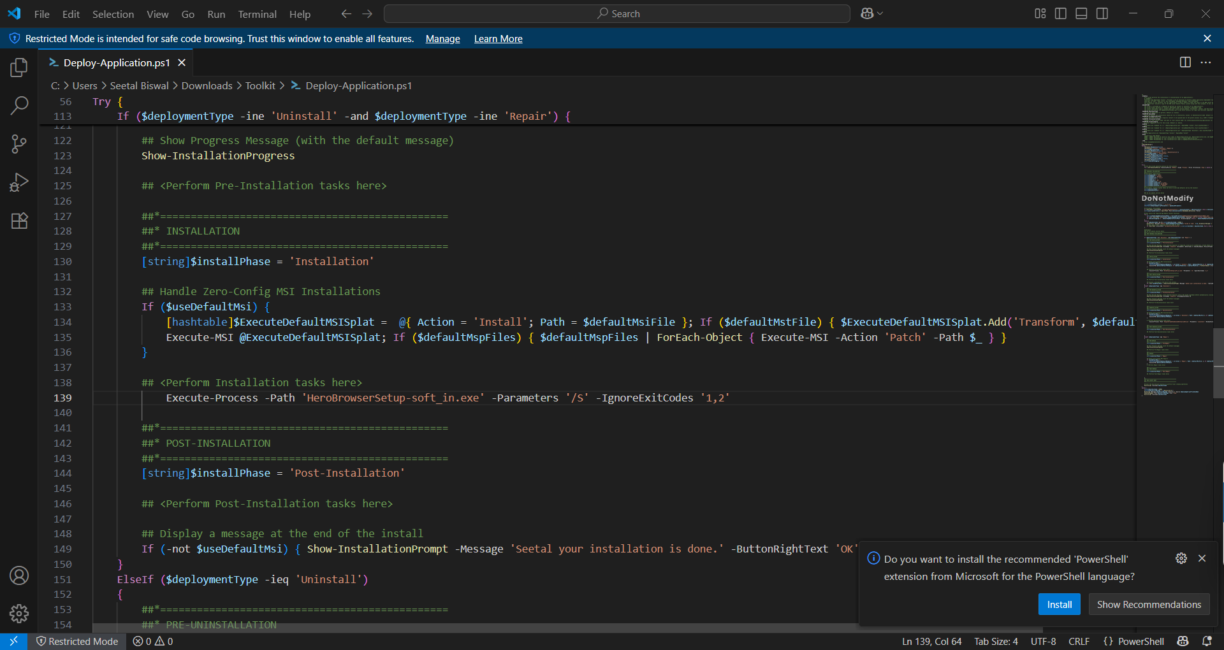

**Example 3:** Execute-Process -Path 'setup.exe' -Parameters "-s -f2`"$configToolkitLogDir\$installName.log`""

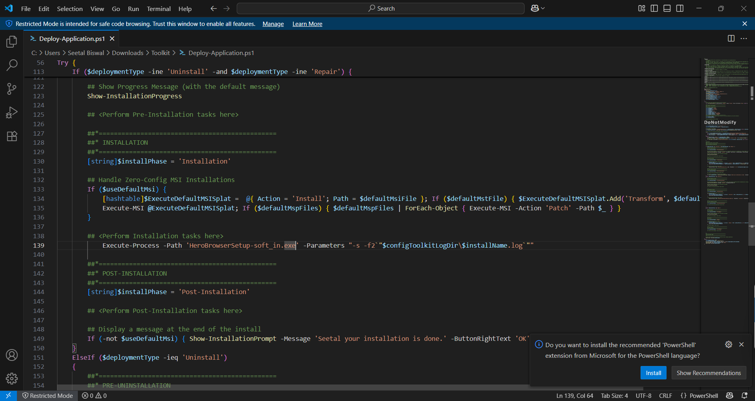

**Example 4:** Execute-Process -Path 'setup.exe' -Parameters "/s /v`"ALLUSERS=1 /qn /L* `"$configToolkitLogDir\$installName.log`"`""

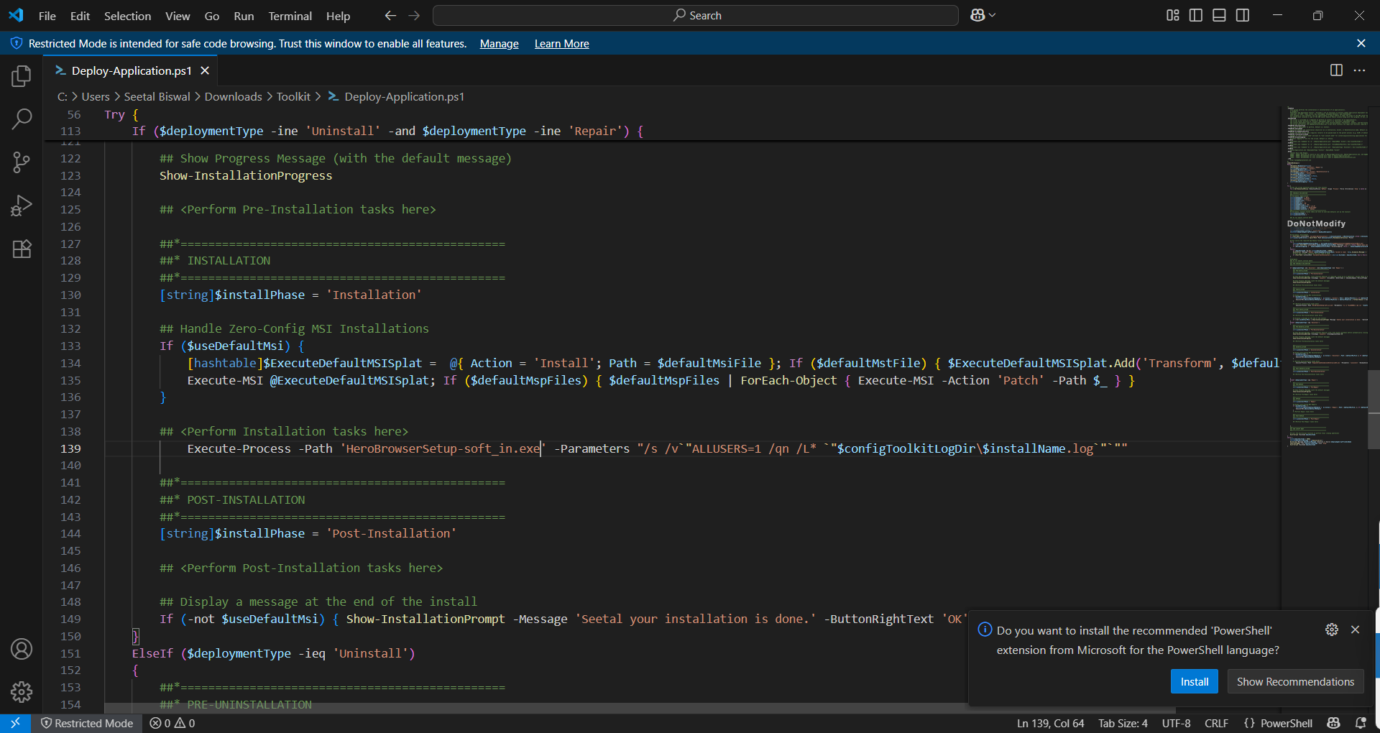

**Execute MSP:** Execute-MSP is a command used in some automation tools, such as PowerShell App Deployment Toolkit (PSADT), to execute a Microsoft Patch (MSP) file.

**Example 1:** Execute-MSP -Path 'Adobe_Reader_11.0.3_EN.msp'

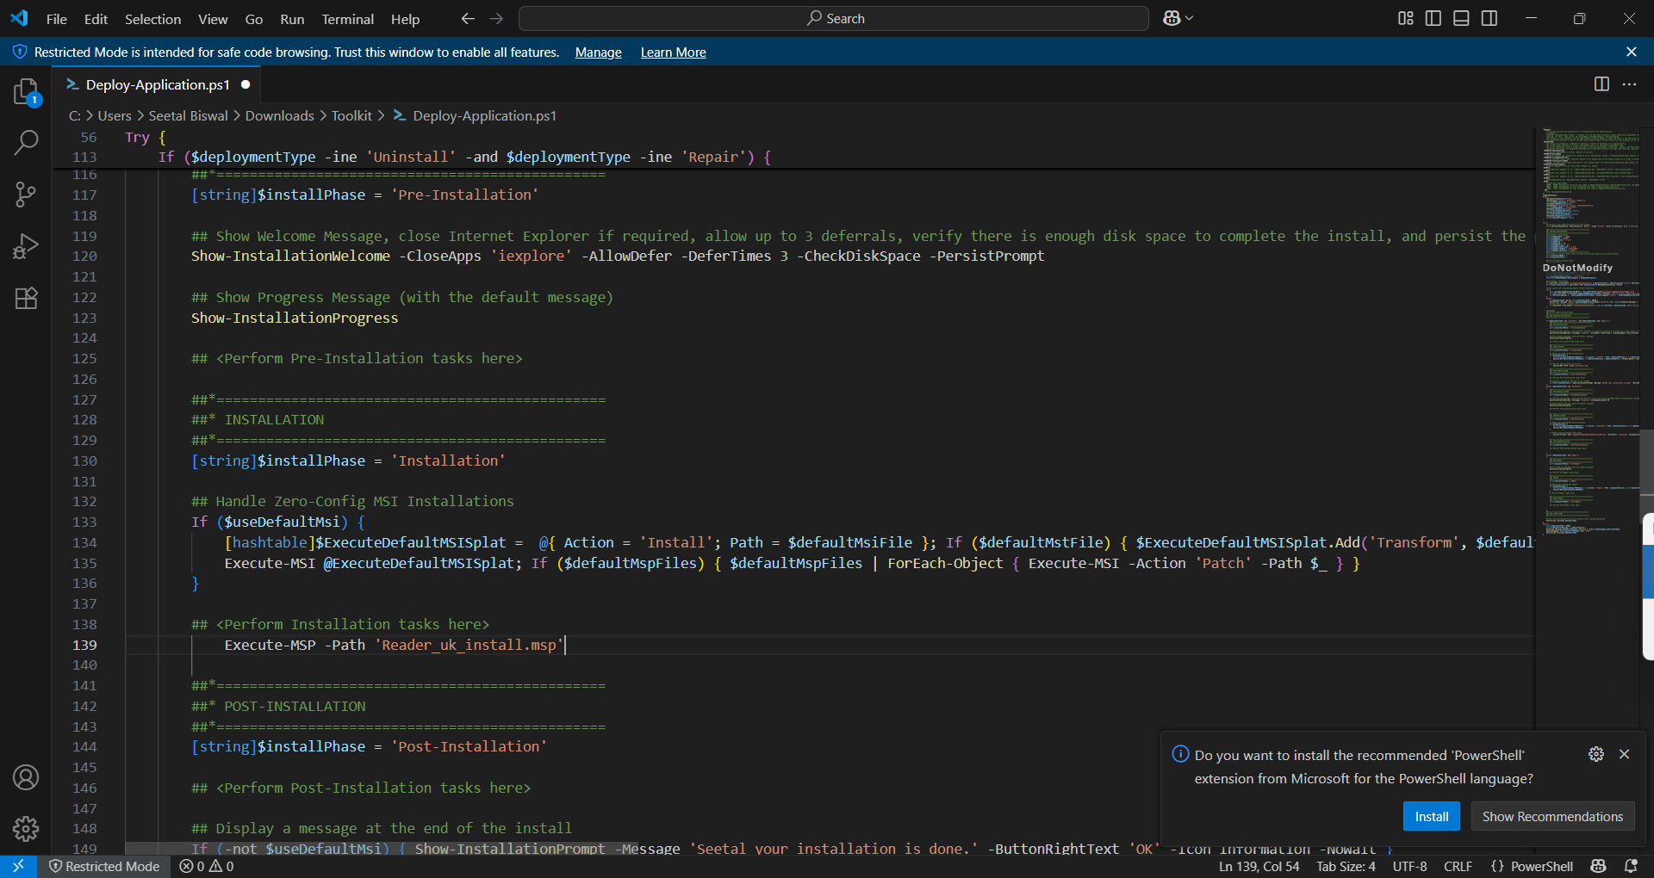

**Example 2**: Execute-MSP -Path 'AcroRdr2017Upd1701130143_MUI.msp' -AddParameters 'ALLUSERS=1'

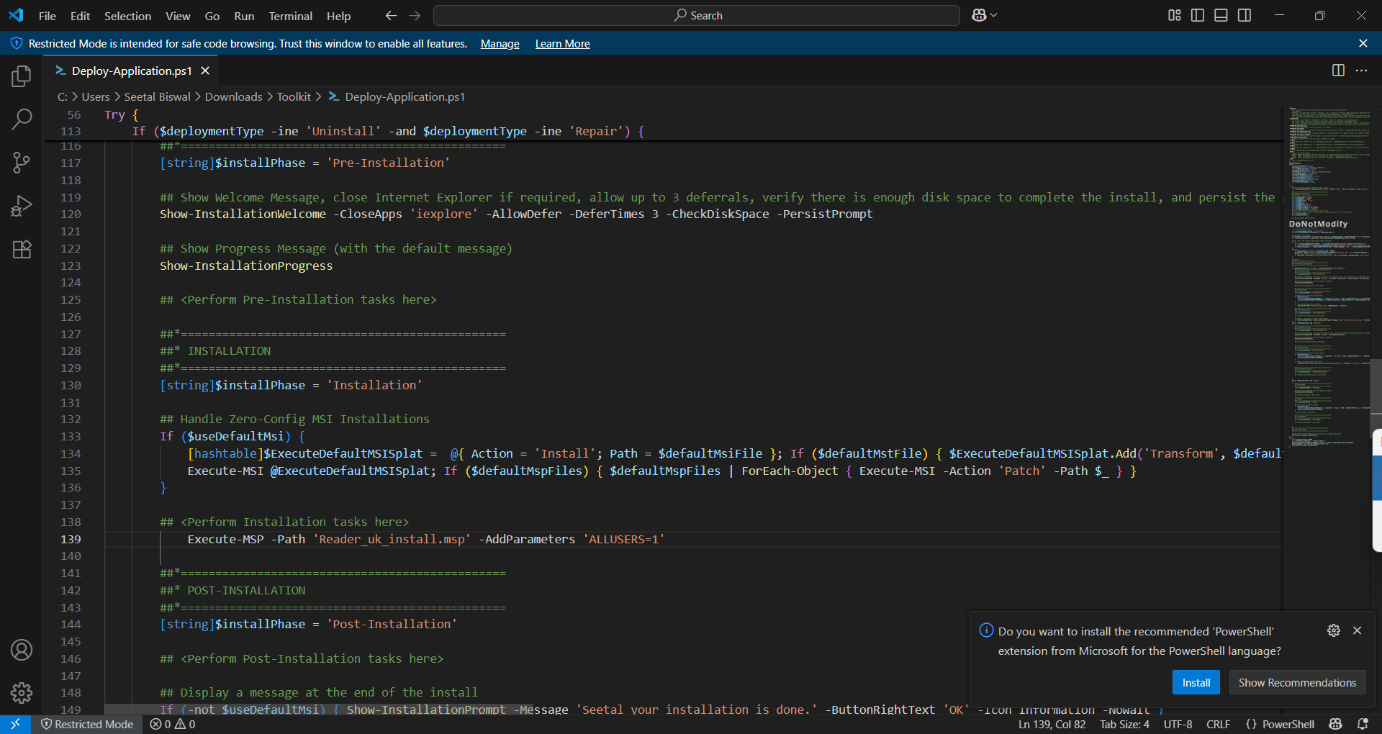

**Copy Items:** Copy-Item is a PowerShell cmdlet used to copy files and directories. Copy-Item allows you to copy files and directories from one location to another.

**Example:** Copy-Item -Path "C:\Source\Folder" -Destination "C:\Destination\Folder" -Recurse

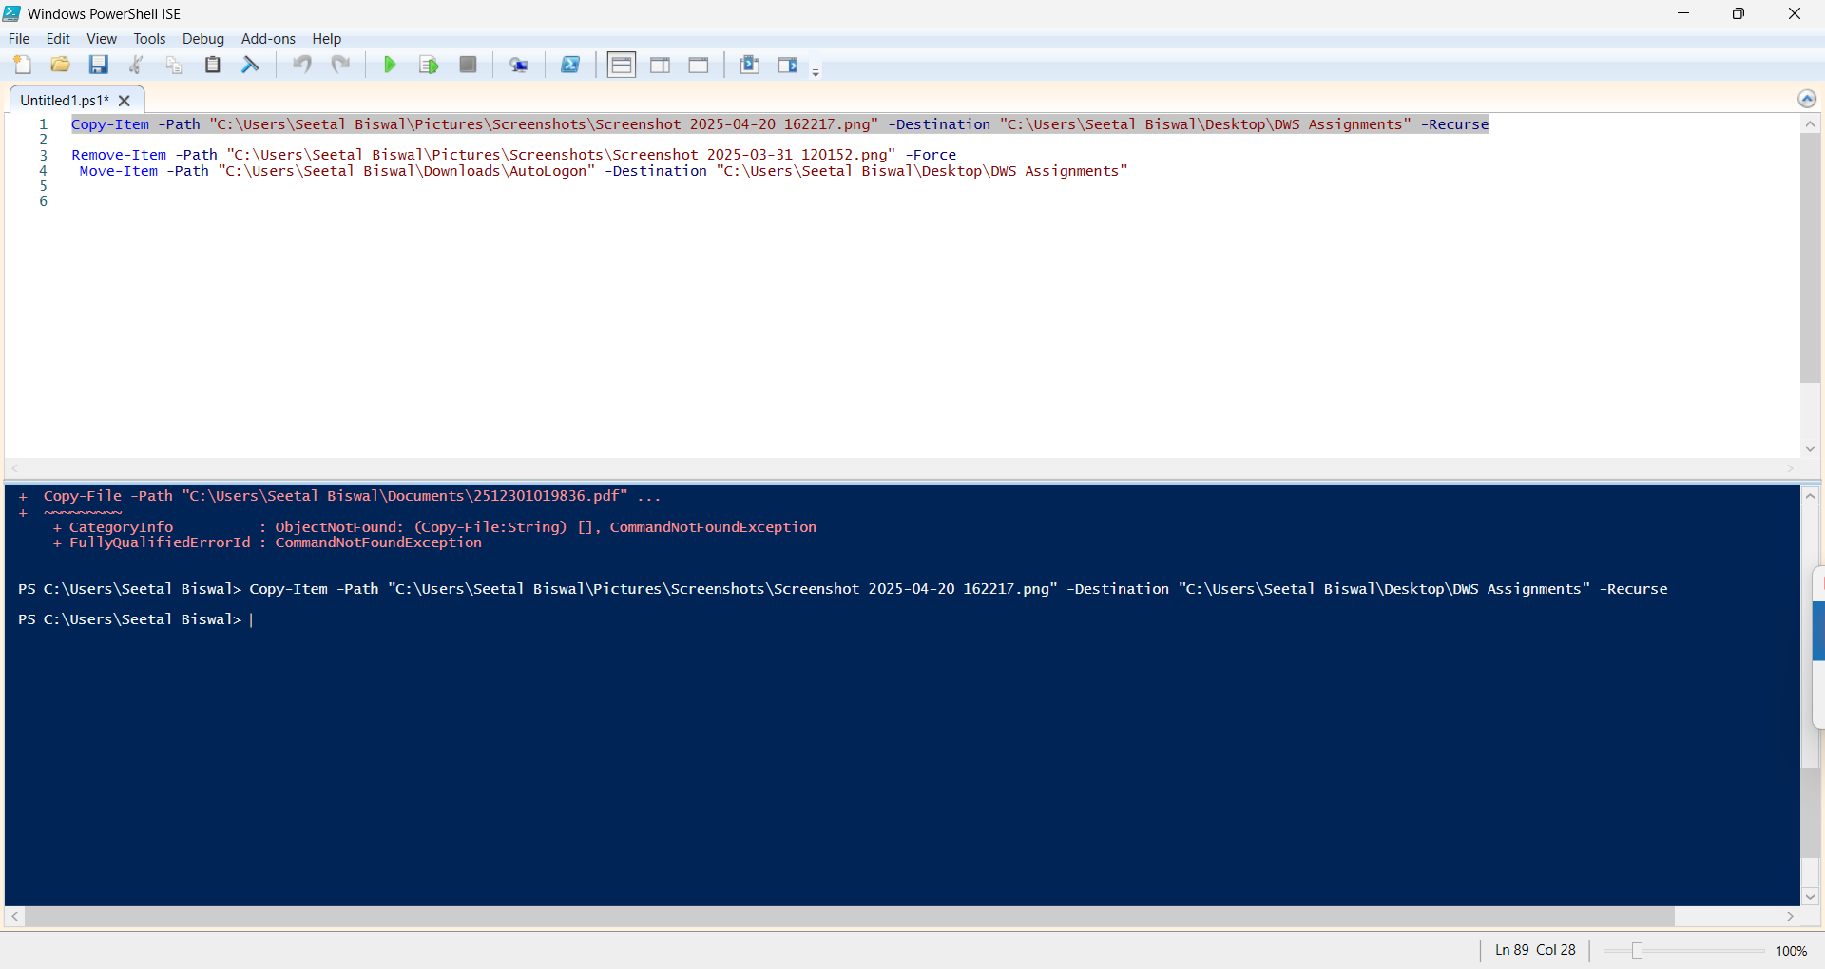

**Remove Item:** he native PowerShell cmdlet can also be used to delete files or folders. Use the -Force parameter to remove read-only or hidden items.

Example: Remove-Item -Path "C:\Temp\OldLog.log" –Force

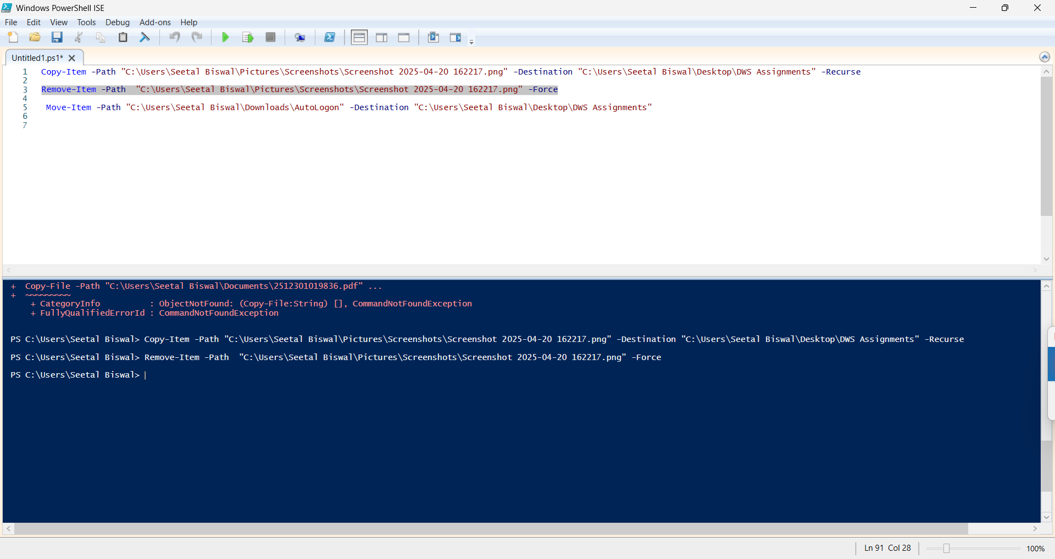

**Move Item:** Move-Item is a PowerShell cmdlet used to move files and directories from one location to another. It allows you to move files and directories from one location to another, effectively relocating them.

**Example:** Move-Item -Path "C:\Source\File.doc" -Destination "C:\Destination\Documents"

